The Fluocell Image Tool
Introduction
Fluocell is a software package for the analysis and visualization of fluorescence images for live cells, with applications in migration and cancer invasion. The main package contains a visualization and quantification tool for fluorescence intensity and FRET ratio images. Optional modules of diffusion analysis and polarity analysis can be obtained upon request. This package is mainly written in MATLAB. It is being developed by a group of researchers at the University of California, San Diego, and the University of Illinois, Urbana-Champaign. As developers, we are open for collaboration on using the software or developing additional features. If you find this software package of interest or useful for your work, please take the time to cite our work and write an email to tell us, since positive feedbacks are important to secure continuous support for this software package.
Citations for publication
- Lu S et al. 2008 PLoS Computational Biology, The spatiotemporal pattern of Src activation at lipid rafts revealed by diffusion-corrected FRET imaging.
- Lu S et al. 2011 PLoS ONE, Computational analysis of the spatiotemporal coordination of polarized PI3K and Rac1 activities in micro-patterned live cells.
Email Contact
Shaoying (Kathy) Lu : kalu@eng.ucsd.edu
Usage
Make sure that the file “pathdef.m” is added to the same directory as “fluocell.jar.”
To Open Fluocell:
- On Windows/Mac
  - Double click “fluocell.jar.” A window should appear and a new session of MATLAB should launch
- On Linux
  - In the terminal, navigate to the directory containing “fluocell.jar.”
  - Enter “sudo java –jar fluocell.jar.” A window should appear and a new session of MATLAB should launch
If MATLAB does not launch when “fluocell.jar” is executed, the path to where MATLAB is installed may need to be specified. To do this, (1) In the java\ folder, make a copy from “default.properties.copy” to “default.properties” (2) if needed, open “default.properties” in the fluocell directory with a text editor, and after “matlablocation=” enter the path to the MATLAB executable or script, found in the /bin directory in the MATLAB installation folder. In Windows, use double backslashes(\\) between directories, since a single backslash is the escape key. (e.g. “matlablocation=C\:\\Program Files\\MATLAB\\2013a\\bin\\matlab.exe”) Currently, it is not possible to use Fluocell with an existing session of MATLAB.

Note: Download the fluocell dataset from here: http://wang.ucsd.edu/~kalu/fluocell_dataset/fluocell_dataset_1.zip , unzip, and the install it to a folder parallel to the fluocell root folder. The relative location of the dataset README file from the fluocell root directory is:
../data/fluocell/README.txt

Visualize the ECFP/FRET Ratio Images

- Open “fluocell.jar.” A new session of MATLAB will be started automatically when the .jar file is run. Make sure the folders “\fluocell_4.2\app” and “\fluocell_4.2\src” are added to the path by clicking on “Set Path” in the MATLAB toolbar, then selecting “Add with Subfolders…” Click “Save” once both folders have been added to the path.

- Select the FRET protocol (highlighted in blue). Also note the first channel pattern, second channel pattern, time frame pattern, intensity, FRET ratio and processing options. These parameters inform the fluocell program the pattern in file names (right panel) and how the user wants to process the images.

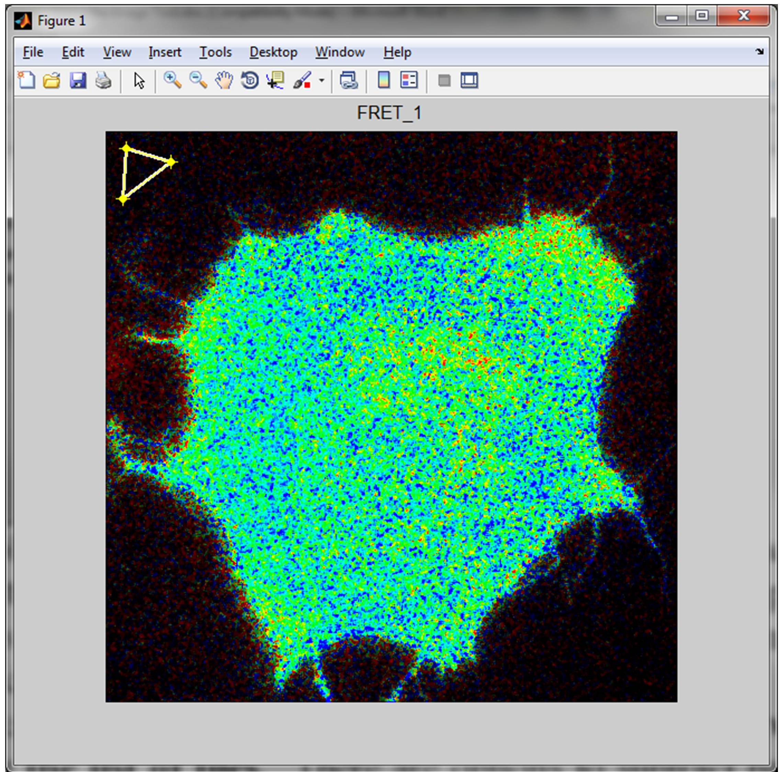
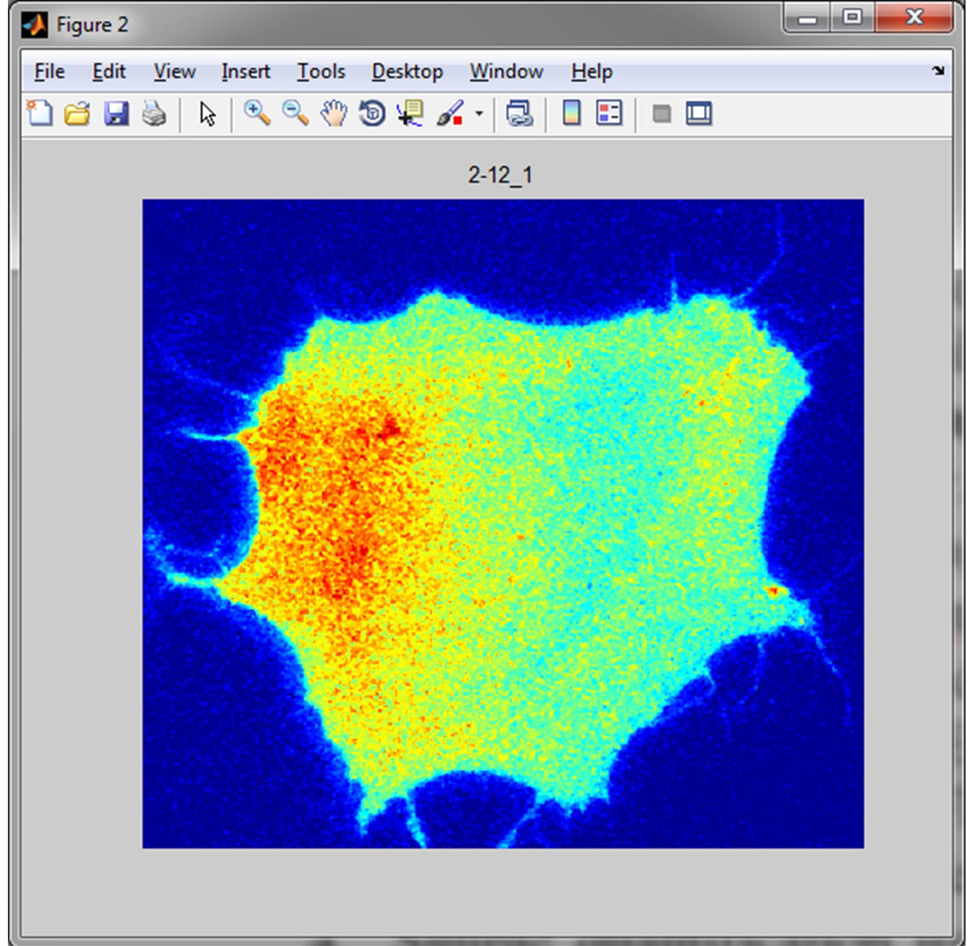
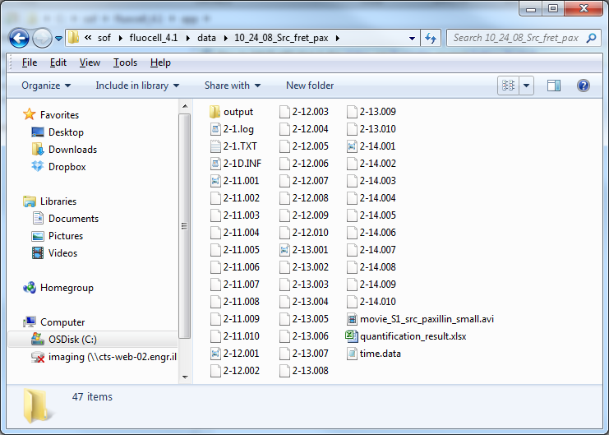
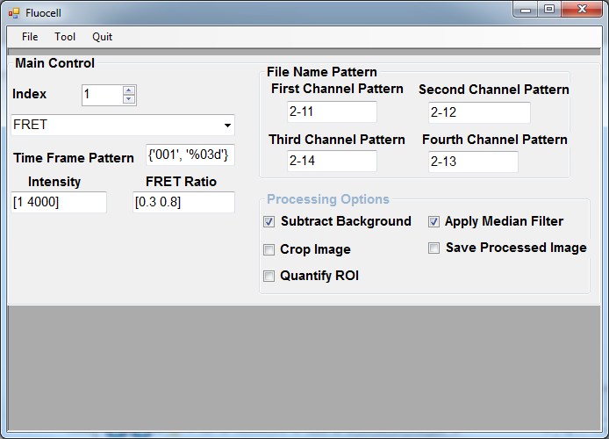
- Open the image files: File -> Open Figure -> Navigate to the image files -> Be sure to open the first channel file among the list of files. Sample data image files can be found in the folder: fluocell\data\ 10_24_08_Src_fret_pax\. The first channel image file is ‘2-11.001’. Note here how the file name patterns including “First Channel Pattern”, “Second Channel Pattern”, and “Time Frame Pattern” etc, are defined in the fluocell main window. As shown to the right, the CFP/FRET ratio image will be displayed in Figure 1 and the intensity image of FRET will be displayed in Figure 2. There are options to subtract background and apply median filter. When the box in front of “Subtract Background” is checked, the default value of “subtract_background” of fluocell_data will be 1. In this case, the background region for background subtraction is selected manually. If user wishes to use the automatic background detection, in the subtract_background parameter needs to be set in the command window:
>> fluocell_data.subtract_background = 2.
In addition, detected boundary can be selected by go through: Tools->Adjust Brightness Factor->Show Detected Boundary. The intensity and FRET ratio information is needed for processing the ratio image. Independently, the intensity of FRET image can be adjusted using the colormap editor by clicking the Figure 2 menu: Edit -> Colormap. The figures can be copied by clicking Alt+Print Screen, or Edit-> Copy Figure, and pasted to a Microsoft PPT file. The processed FRET image can be saved by checking the box “Save Processed Image”. Note once the FRET images are saved, the options Intensity and FRET ratio bound will become ineffective.The background, ROI and processed image files are saved in a subdirectory output/ within the image path. When the user manually change the index, the ratio image will be saved automatically in the path: fluocell\data\10_24_08_Src_fret_pax\output\0.3–0.8 (the range is set in the interface of fluocell under ‘FRET Ratio’). Once user has the ratio images, it is convenient for visual inspection. To remove and re-define these files, the user needs to open the output/ folder and manually removed the saved file and repeat the image analysis steps.

- Close files and quit the image tool: File -> Close -> Quit. Note: it is necessary to close the processed image using fluocell interface cleanly: File->Close Figure instead of closing it directly.

Quantification using regions of interest (ROIs).
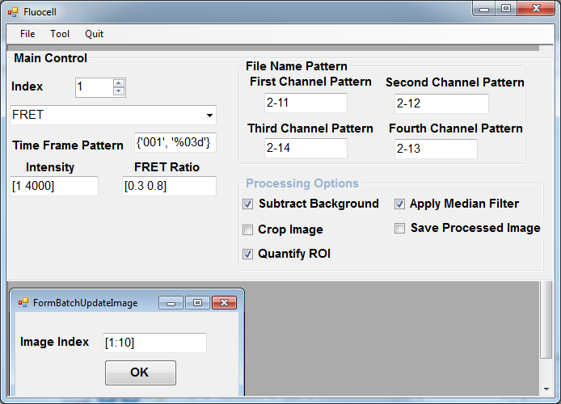
- At the Fluocell Menu, check the box “Quantify ROI”.
- Batch process: Tool -> Batch Update Image -> To process images from 1 to 10, set Image Index to [1:10] -> click ‘OK’ only once.

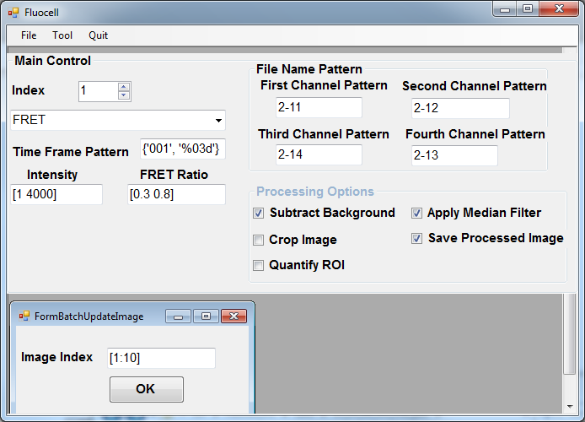
- To retrieve data, copy the output variables from the MATLAB Workspace to Excel: fluocell_data -> time, fluocell_data -> value. The fluocell_data.time variable has two columns. The first column contains the index number of the image frames. The second column contains the time that the image frames were saved, in minutes starting from 12:00am of the day.

Make Movies
- Choose settings and open a figure by going to File -> Open Figure
- Save Ratio images by checking the box “Save Processed Image”, and in Tools -> Batch Update Image enter the range of files (e.g. [1:10]), click ok. The processed images have been saved as .tiff files in the data folder. The previous steps do not need to be repeated for multiple movies unless the images need to be processed with different parameters.
Note: In order to allow “Save Processed Image” to function, you need to have writing permission in the data folder. If not, copy the data folder into another folder where you have permission to write files.
- Once the images have been saved, in the MATLAB command window type
>> data = sample_init_data('src_pax','make_movie');
>> make_movie(data);
The function make_movie() takes pre-existing images (.tiff) and assemble them into movies. The movie file “fret.avi” can be found in the “output\” folder within the data folder. Note: this feature currently does not work with Intensity-Processing and Intensity-DIC-Processing protocols

Visualize the Intensity Modified FLIM Images
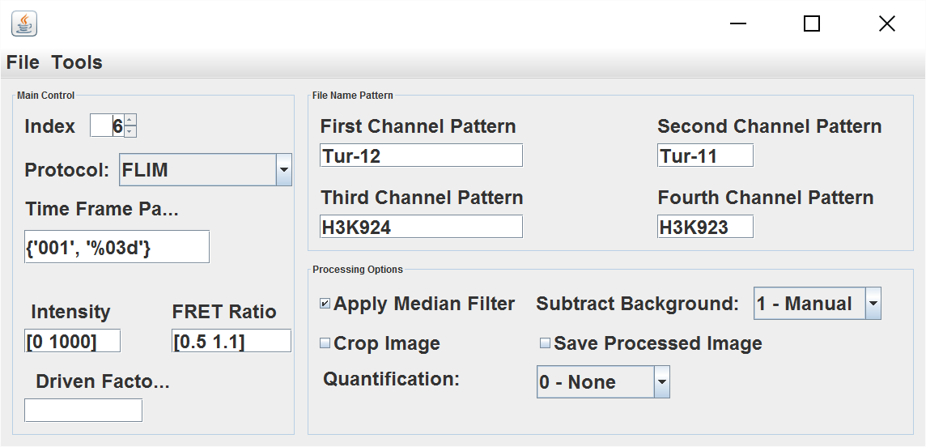

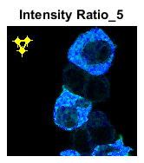

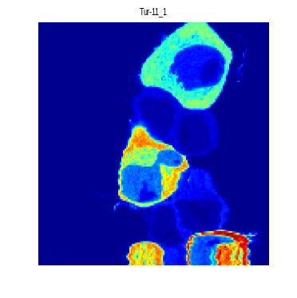

Polarity Analysis
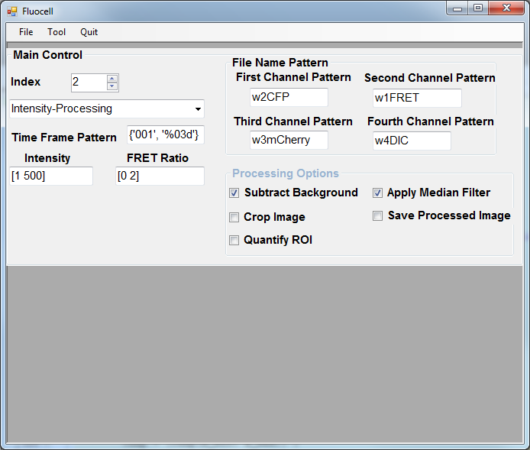
Rotate the cells to horizontal position and quantify the polarity of signal. An example using the sample data:
- Open the Image.
- Fluocell Menu -> Protocol -> Intensity-Processing, Time Frame Pattern:{‘001’,’%03d’}; check the boxes “Subtract Background”, “Apply Median Filter”. Leave the rest to default values.
- Open the image files by selecting File -> Open Figure. Navigate to the data folder C:\sof\fluocell_4.1\data\PH-Akt-GFP_1\ -> double click the file “AKT-PH-YFP_PDGF52.001”.
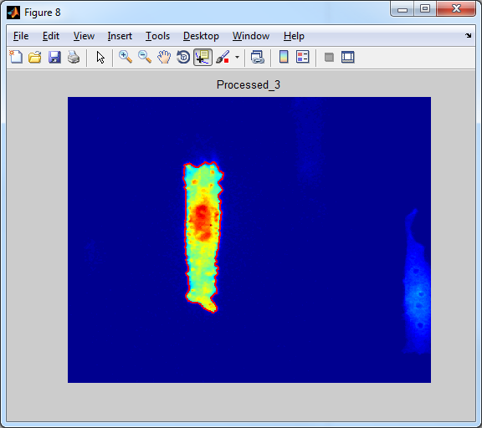
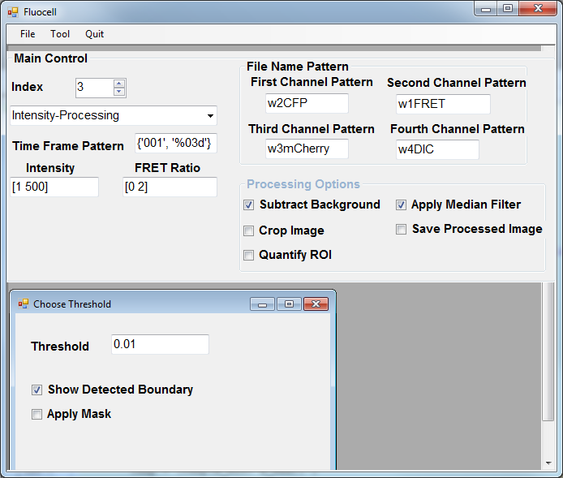
- Decide the threshold for cell detection.
Menu-> Tool -> Adjust Brightness Factor; Brightness Factor 1.0, check the box “Show Detected Boundary”. Change the index value to show the boundary. Adjust the colormap to 0-5000 or as needed.

- In the file sample_init_data.m, change the value of root to the path of the data directory
- Run the polarity quantification scripts
>> cd app/
>> cell_name = 'akt_1';
>> data = sample_init_data('akt_1');
>> single_cell_analyzer('akt_1',data);

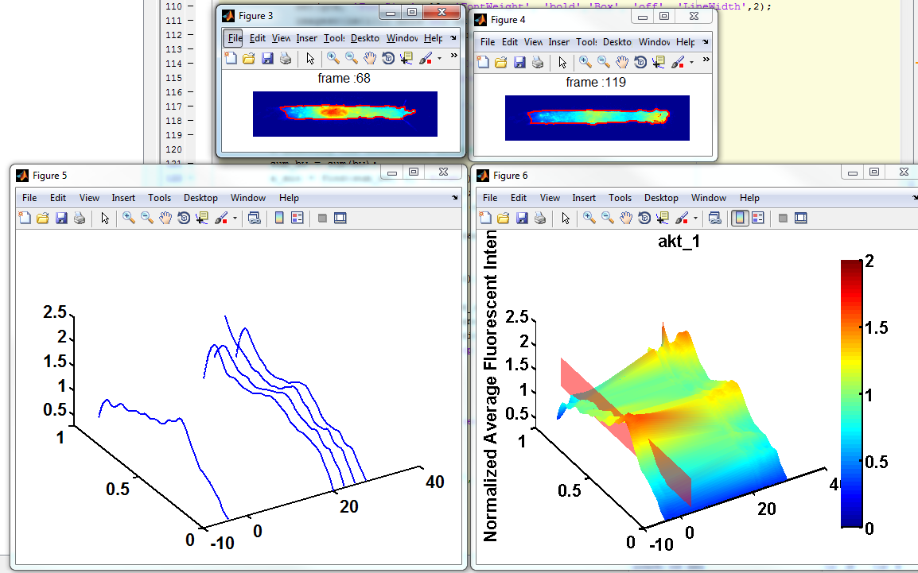

- Tracking Cells and Regions of Interest
>> fluocell_data.num_rois = 3;
Navigate to the examples: tracking_ex/ folder.

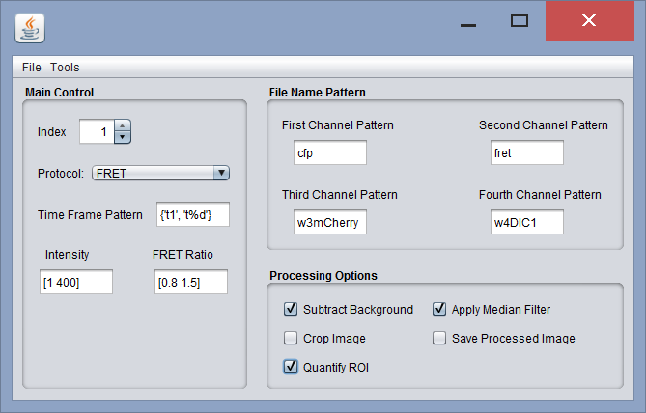
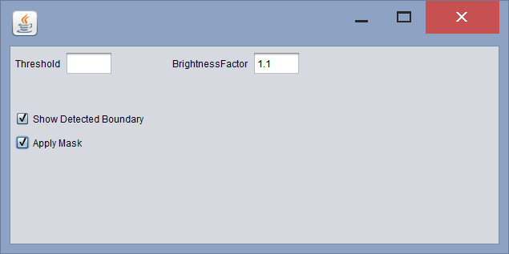

In Matlab Command window:
- >>fluocell_data.quantify_roi = 0; There will be no quantification on region of interest.
- >>fluocell_data.quantify_roi = 1; Quantifying the region of interest without tracking cell;
- >>fluocell_data.quantify_roi = 2; Quantifying the region of interest with tracking cell. Note here that the option to “Apply Mask” may create a conflict as Fluocell detects another cell in the mask and move the ROIs by mistake. To avoid this conflict, we need to close the figures and re-open the figures each time when the “Apply Mask” is checked or unchecked.
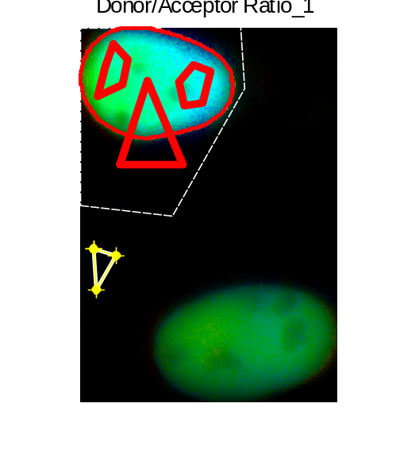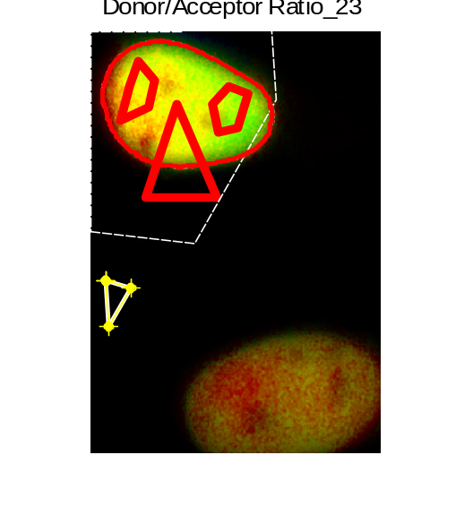
- >>fluocell_data.quantify_roi = 3; Quantifying use subcellular layers instead of ROIs; In this case, the default number of layers is 1 and user can change it by
>>fluocell_data.num_layers = 3;
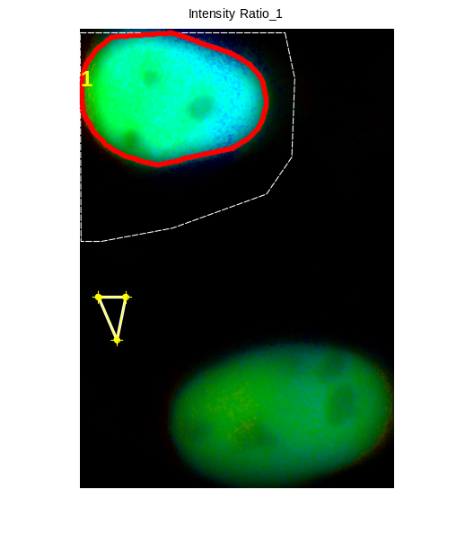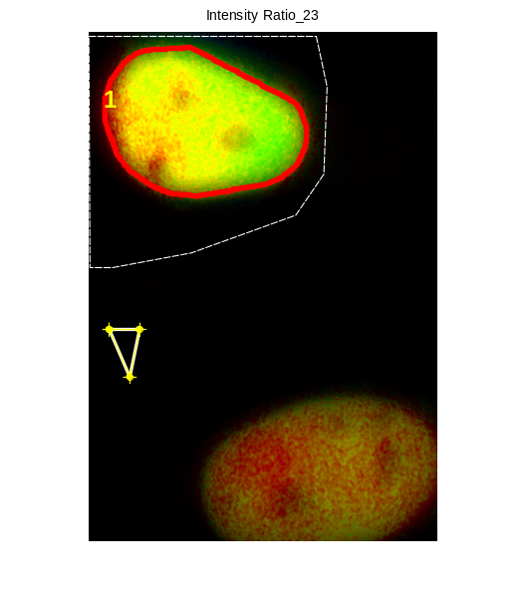
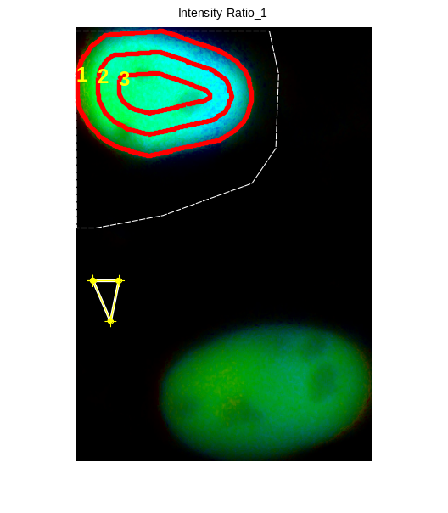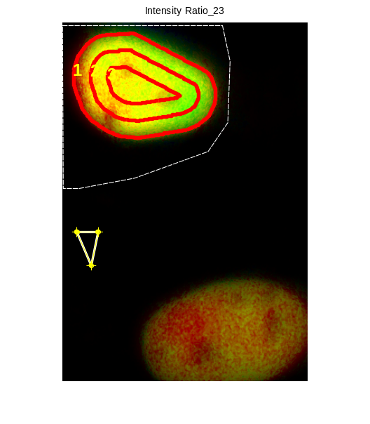

Output: fluocell_data.time, fluocell_data.ratio, fluocell_data.donor, fluocell_data.acceptor

FA Detection and Subcellular Quantification
- Detect cell mask. The following commands will detect a sequence of cell mask and output mask files to the subfolder output/
>> cd ../../app/fa_analysis/
>> cell_name = 'src_pax';
>>data = sample_init_data(cell_name, 'batch_detect_cell');
>>batch_detect_cell(cell_name, data);
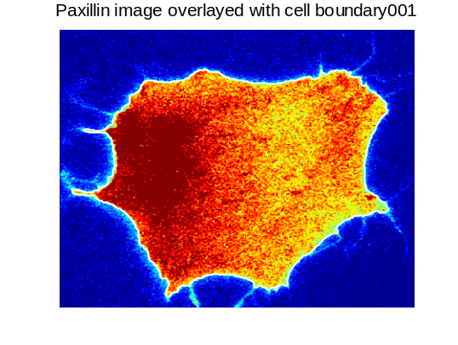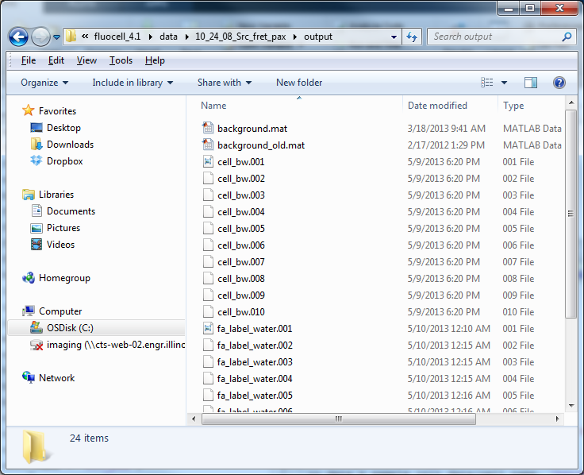
- Detect Focal Adhesions
>> cell_name = 'src_pax';
>> data = sample_init_data(cell_name, 'batch_detect_fa');
>> batch_detect_fa(cell_name, data);
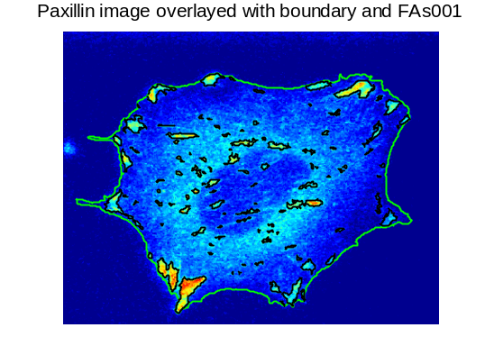
- Programs to quantify local FRET ratio and FA intensity.
>> compute_fa_property(cell_name, data);
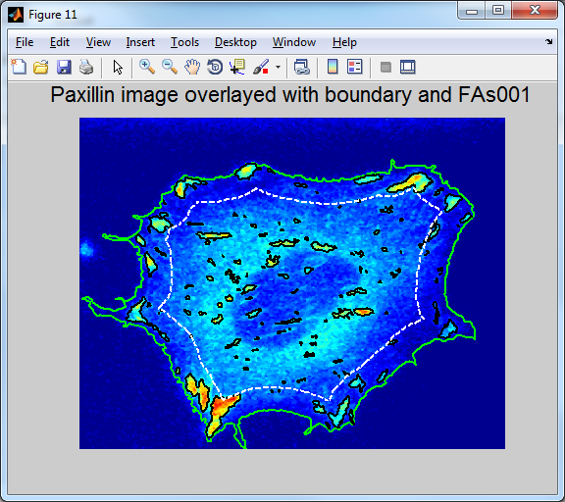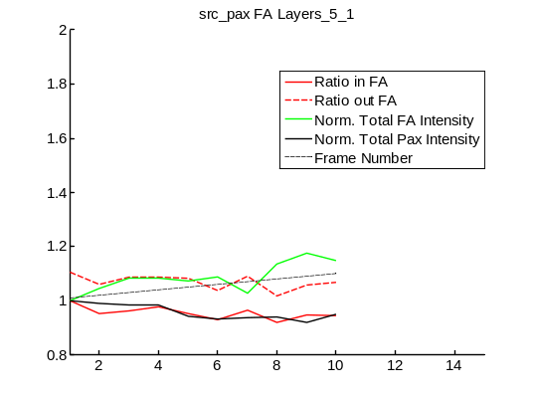

Useful Fluocell Functions:
It is required that the image sequence of each cell is located in a separated folder. This function can be used to divide multiple position data into different folders: batch_sort_file_multiple_position(path, sub_dir). Note: please don’t name a file with any space, which may confuse MATLAB programs.
- Example:
>> path = 'E:\sof\fluocell_2.1\data\migration\07_01_2010\';
>> sub_dir = {'FN5\2_2\', 'FN5\2_3\', 'FN5\2_FBS10\', 'FN10\1\', 'FN20\1\'};

>> batch_sort_file_multiple_position (path, sub_dir)
- Different types of regions of interest. By default, fluocell allows the user to choose a region of polygonal shape which is supplied by the user. There is an additional option to choose a circular region of a fixed diameter. This can be set up in MATLAB by
>> fluocell_data.roi_type = ‘circle with fixed diameter’;
>> fluocell_data.roi_diameter = 100;
If you want to switch back to a polygon region, simply remove the roi.mat file from the ourput/ folder and set:
>> fluocell_data.roi_type = ‘any’;
>> fluocell_data.roi_diameter = 0;

Frequent Asked Questions

- What is the channel patterns and time frame pattern for the images obtained using software other than metamorph.
Answer: The channel patterns and time frame pattern are provided by the user to help Fluocell to recognize the donor and acceptor image files. The default values will work for the image files obtained from out Nikon microscope via metamorph. For example, the image files have the names such as fret11.001, fret11.002, …, fret12.001, fret12.002 etc.
The first channel pattern: fret11 ; the second channel pattern: fret12; the time frame pattern: {‘001’, ‘%03d’}, where the pattern string ‘%03d’ follows the convention in C++ or MATLAB, meaning an integer of 3 digits padded by 0. And the string ‘001’ should match the first donor image file that you click when opening the image. In another example, the image files have the names such as cfp_t1.tiff, cfp_t2.tiff, …, yfp_t1, yfp_t2 etc.. The first channel pattern: cfp; the second channel pattern: yfp; the time frame pattern:{‘t01’, ‘t%d’}, where ‘t%d’ means the letter ‘t’ followed by an integer.

- The first images opened correctly, but Fluocell cannot navigate through the time sequence.
Answer: The Fluocell software use “time frame pattern” submitted by user to recognize file names and navigate through the time frame. For example, if the first image file has the pattern filename_t1.TIF, the software will replace ‘t1’ with ‘t2’, ‘t3’, ‘t4’ etc. But, if fret18_t1.TIF. In this case, Fluocell will think the next file in the time sequence as fret28_t2.TIF by replacing ‘t1’ in two places the file name. In order to fix this problem, the file name pattern need to be defined as {‘_t1’, ‘_t%d’}, so that Fluocell can correctly replace the unique pattern ‘_t1’ with ‘_t2’, ‘_t3’, ‘_t4’ etc.

Note: Moving the Fluocell folder between operating systems may cause problems to arise. If Fluocell needs to be run on multiple systems, it is recommended that each system download its own copy of the Fluocell program.

Installation Instruction
- In all operation systems, identify the location of fluocell programs in MATLAB.

>> cd fluocell/src

File -> Set Path -> Add Folder -> double click the folds to add -> api\, detect\, post\, pre\, track\, vis -> Save
The resulting pathdef.m file should be saved either to its default location or same directory as “fluocell.jar” (usually in fluocell/src/gui/java/dist/).
- In Windows, setup MATLAB startup script for fluocell
The MATLAB startup file "startupsav.m" can be found at ‘matlabroot\toolbox\local\’, where matlabroot is usually ‘C:\Program Files\MATLAB\R2013a’.
The user can copy the file ‘startupsav.m’ from ‘matlabroot\toolbox\local\’ to your local MATLAB root ‘username\MATLAB\’ if it’s not already there. Comment the existing lines and add one line to the file.
enableservice('AutomationServer',true)

Updates
- Version fluocell-4.3, revision 149.

